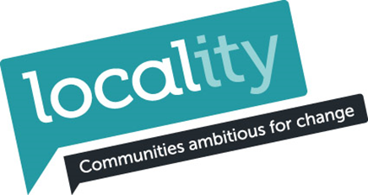
Gedling Asset Transfer Funding Opportunities February 2016
There are ongoing funding programmes from a range of sources including Lottery, trusts, funds and public agencies which will provide opportunities to access both capital and revenue funds. Below are a few sources which may provide opportunities in 2016 whilst recognising there are many programmes opening and closing at any one time.
Below provide examples of capital and revenue funding opportunities. In developing your business plan and taking over an asset you may need to undertake capital work/improvements or need revenue for posts.
One challenge you will quickly find is that there are limited funders who will provide core costs.
Coalfields Regeneration Trust
http://www.coalfields-regen.org.uk/what-we-do/social-investment/coalfields-community-investment/
The total fund value of £500,000 will be committed over the period 1st April 2016 to 31st March 2017 at four decision making Committees which will take place quarterly (£125,000 allocated to each Committee). The first of these will take place in April.
Applications can be submitted for up to £10,000 (with a maximum of £5,000 on capital items).
Revenue funding – this refers to the direct costs of delivering a service/project such as salary costs, sessional staff fees, training fees or rent. The total requested cannot be more than £10,000. If the costs are above £10,000 you must have the rest of the funds already secured and be able to evidence this.
• Capital funding – this refers to the costs of physical items such as equipment costs, furniture, computers or small scale refurbishment of buildings. You cannot request more than £5,000 in total for capital costs. If you need to spend more than £5,000 on this you must have the rest of the funds already secured and be able to evidence this.
NB :If you apply for both capital and revenue funding, the combined total cannot be above £10,000 and the capital costs should not exceed £5,000.
Eligible ward areas in Gedling include: Bonington, Calverton, Daybrook, Killisick (high priority), Pheoxnix, St Mary’s and Valley
The committees are themed as:
- April 2016 Committee (Skills)
- July 2016 Committee (Employment)
- October 2016 Committee (Health)
- January 2017 Committee (Skills)
http://www.coalfields-regen.org.uk/wp-content/uploads/2016/02/CCIP-Eligibility-Survey-Guidance-Notes-V2-final.pdf
I have spoken with Steve Abson (01226 272818) from CRT who said:
- they are seeking projects which provide a direct benefit to eligible community areas so you could still be eligible even if the centre is not in the ward if the majority of users are from the ward
- skills is the most likely theme for applications from you – the application can cover a number of aspects so could include some capital costs if they help deliver the skills element
- don’t all put the same type of application in – so perhaps collaborate on focus so they are different
- if you are not sure about whether the project is in an eligible area contact them
In addition, they can provide you with support and access to lots of information to use and are interested in community asset transfer.
Now is a good time to join the programme as we have the software to produce detailed area reports, each report contains around 40 pages of information specifically highlighting the issues in any given geographical area. Feedback from existing Enterprising Communities Programme members has been very positive and the reports are provided for free to members to assist with applications for funding, for helping to identify specific needs and inform business plans for example. We are also about to launch the Enterprising Communities Resource Library which will be an online source of information and reports about a variety of different subjects of relevance to charitable organisations and social enterprises. There are currently over 700 reports and other information that will become available in the next week or so. This is in addition to the range of other benefits and services available.
Access to the Enterprising Communities Development Fund (ECDF) grant is time limited as the deadline for applications has been set as 11th March 2016 and the remaining funds will be allocated on a first come first served basis. The ECDF grant will pay up to £2,000 for the costs associated with developing a business plan, the costs of acquiring a quality mark or obtaining external accreditation. More information will be provided if your organisation chooses to join the Enterprising Communities Programme.
Please see below and attached more information about the Enterprising Communities Programme.
The ECP Eligibility and Offer document explains what the programme is about and what you can expect to receive.
Access to the programme is via the online Organisational Diagnostic Tool. I've attached a pdf version of the Organisational Diagnostic Tool to give you an idea of what to expect on the online version and its worth having a read through prior to starting the online version which can be found by clicking the following link when you are ready to start filling it in online.
https://www.surveymonkey.com/s/Enterprising_Communities_Self-Assessment_Form
Please don't complete the pdf version as we are keen to collate the results online.
The form will probably take 30-60 minutes or so to complete and unfortunately it has to be completed in one go as there is no capacity to save it part way through. That said many of the organisations who have completed the form found it a useful exercise as it will provide a snapshot of your organisation's current position and gives me a baseline position and an idea of your development needs which will guide me to provide you with the most effective support.
Lloyds Bank Foundation
Is active locally and have a number of programmes. These include invest
Invest http://www.lloydsbankfoundation.org.uk/our-programmes/invest
Enable http://www.lloydsbankfoundation.org.uk/our-programmes/enable
Enhance http://www.lloydsbankfoundation.org.uk/our-programmes/enhance

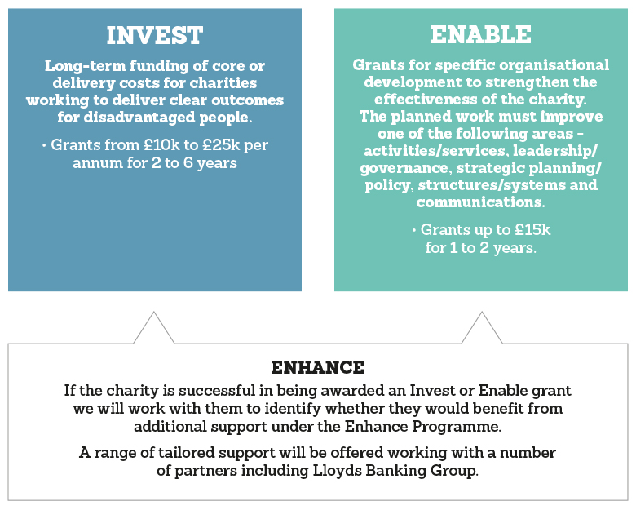
Gary Beharrell is a local contact http://www.lloydsbankfoundation.org.uk/contact-us
http://www.lloydsbankfoundation.org.uk/our-programmes/
Big Lottery Fund
Reaching Communities
Reaching Communities funding is for projects that help people and communities most in need. Grants are available from £10,000, upwards and funding can last for up to 5 years. If you think you need more than £500,000 you must call us before you apply to discuss why you believe a larger project is appropriate. There is no upper limit for total project costs.
https://www.biglotteryfund.org.uk/prog_reaching_communities
Paola Torres Silva is based in Nottingham and could be a useful person to talk to alternatively there is the Help line http://ask.biglotteryfund.org.uk/help/england/reaching/
It is a 2 stage process and you should expect at least 6 months before you get a decision
Reaching Communities Buildings
The buildings strand of Reaching Communities provides funding for land and buildings projects costing more than £100,000. It can also provide revenue funding to help to get the building running and deliver project activities.
For more information read the Reaching Communities buildings Stage One guidance notes.
Funding is available for building grants up to 2015 and there are currently no deadlines for applications. However, the programme is regularly reviewed and you are encouraged to apply as soon as you are ready.
The funding is targeted at those “most in need”, and targeted at buildings or sites based in the most deprived ‘Lower Super Output Areas’ in England. To check whether your project is eligible use the eligibility checker http://services.biglotteryfund.org.uk/PostcodeCheck.aspx?SID=2
The application process
First of all you need to check your eligibility. If you are able to apply, contact the Big Advice line (0845 4 10 20 30) before you complete a Stage One application form.
If you are invited to apply, you will be sent a Stage Two application form which you will have three months to complete. If you are successful at Stage Two BIG may consider giving you development funding to help you with your plans to develop your project. Finally, BIG will ask you to submit your Stage Three application within six months, which will include a business plan
https://www.biglotteryfund.org.uk/global-content/programmes/england/reaching-communities-buildings-england
There are 3 stages and the timescales can be over 1 year
Awards for All
Awards for All offers grants of between £300 and £10,000 for grassroots and community activity that aims to improve life for local people and neighbourhoods. It doesn’t have a deadline and you can apply at any time. There is a wide variety of funding available which includes capital and revenue.
https://www.biglotteryfund.org.uk/global-content/programmes/england/awards-for-all-england
The success rate has previously been around 70% but this has declined recently due to demand but is still over 50%
Heritage Lottery Fund
This may be a long shot for some of you but there may be opportunities to access grants for start--up or for specific projects. Gedling is a priority area HLF regionally and so they will be interested in hearing of your ideas. A good local contact is Sarah Burgess, Development Officer, sarahf@hlf.org.uk
https://www.hlf.org.uk/looking-funding/our-grant-programmes
WREN
FCC Community Action Fund
£2,000 to £50,000 grants available
WREN will only fund costs which are specific and wholly attributable to a project’s delivery. Work could include physical improvements to a facility, i.e. new windows, access improvements, refurbishment work or landscaping. Physical improvements covers a wide range of work, if you are unsure about your project please call for advice
http://www.wren.org.uk/apply/wren-grant-scheme
WREN uses a calculator to see if areas are eligible to apply based on distance from a waste plant http://www.wren.org.uk/apply/distcalc
Jane can you clarify if groups are still eligible to apply once Docket Head closes please????
There are other useful funding sites to be kept up to date such as Funding Central being a free one
http://www.fundingcentral.org.uk/default.aspx

Mick McGrath
Locality
Mick.mcgrath@locality.org.uk
February 2016

